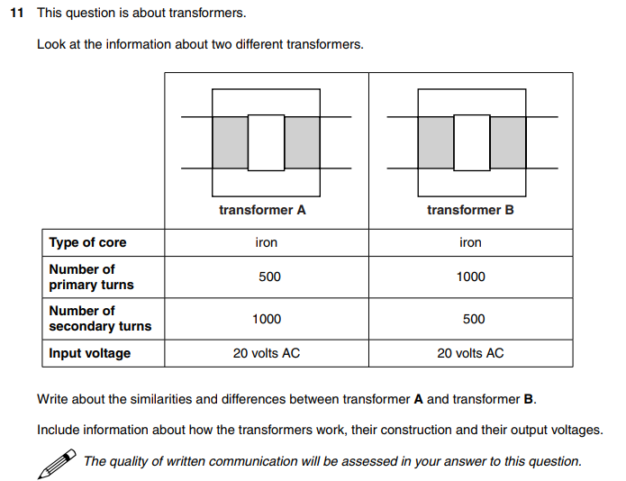
Transformer exam style question

This answer would easily gain full marks
- Both transformers utilise a soft iron core with a primary and secondary coil that are linked by changing magnetic flux.
- Both have different output voltages compared to their supply (20V a.c.) .
- Transformer A will output ~40V but transformer B will output ~10V (calculated using the transformer equation).
- Transformer A is a step-up transformer whereas transformer B is a step-down transformer.
- Both transformers function the same:
- Transformers of this type work by an alternating current that is supplied to the primary coil. This induces a changing magnetic field in the soft iron core.
- The secondary coil is wrapped round the same iron core and is linked to the primary coil by the changing magnetic flux which cuts it.
- According to Faraday’s law of electromagnetic induction, this induces and alternating e.m.f across the secondary coil so long as it is not part of an external circuit.
- If this is the case, however, an alternating current is induced in the secondary coil.
- The difference in the number of turns on the primary compared to the secondary (ratio of no. of turns) determines whether the transformer is a step-up or step-down as shown by the transformer equation.

$$\frac{Vs}{Vp}=\frac{Ns}{Np}$$

