Moments question – Physics style practice

- a State two conditions that are required for an object to be in equilibrium under the action of several forces.

(2 marks)
b Figure 23 shows a mobile crane used to lift building materials. When lifting, the base of the crane rests on support legs at P and Q. The base of the crane has a weight of 2.4 × 10⁵ N and acts through its centre of gravity G. The telescopic jib has a weight of 2.8 × 10⁴ N, which acts through the centre of the jib when it is fully extended to 25 m.
The crane is used to lift a load of 1.2 × 10⁵ N placed 6.0 m from the support legs at Q. The jib is fully extended and at an angle θ to the horizontal.
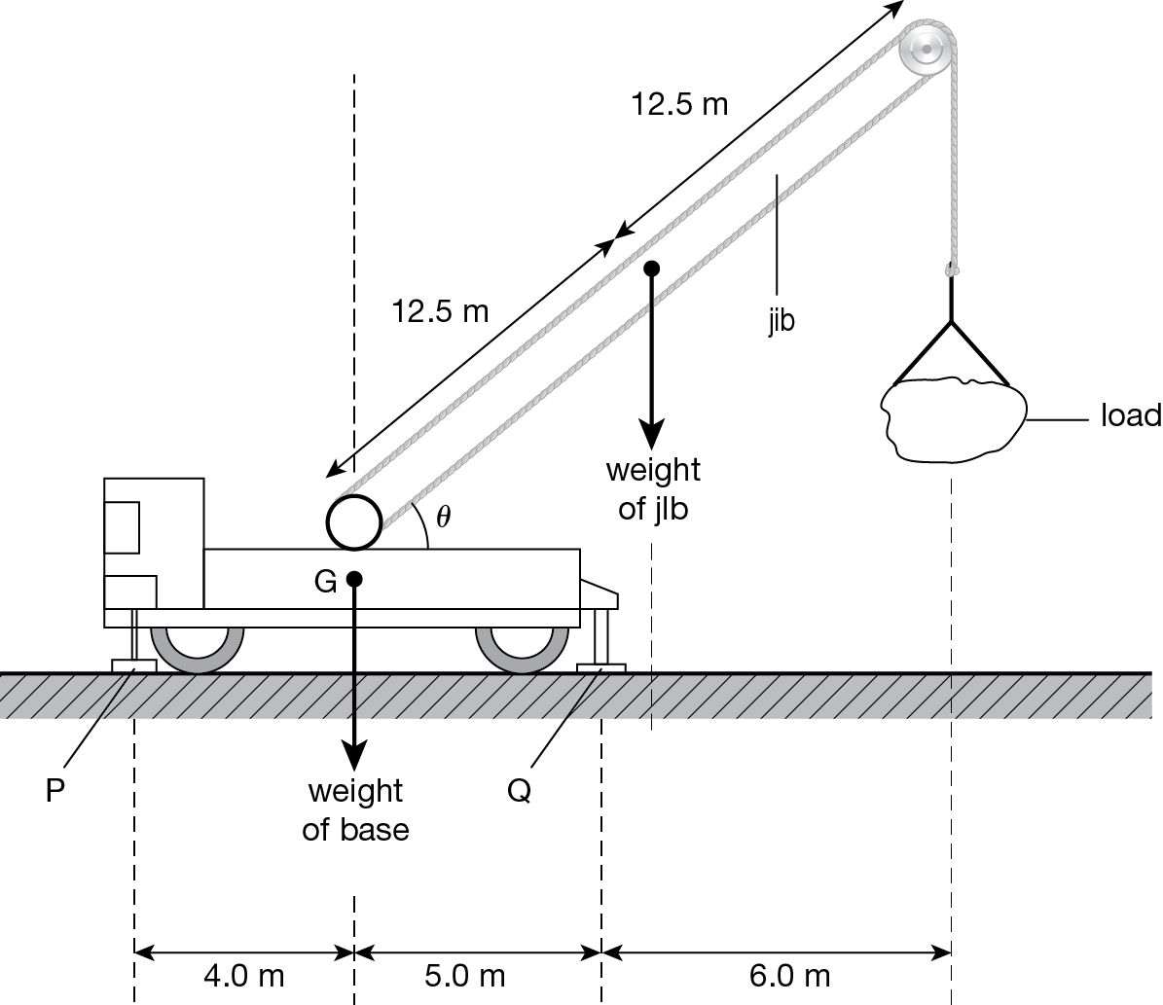
Figure 23
Calculate:
    - the total normal contact force at P, F_{P}

F_{P} = N (3 marks)
    - the total normal contact force at Q, F_{Q}.

F_{Q} = N (1 mark)

