CARBOXYLIC ACIDS, AMINES, ESTERS AND ACYLATION

HW MS

1. (i)
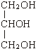
1
propan(e)-1,2,3-triol
OR
1,2,3-propan(e)triol
OR
Glycerol;
1
(ii) CH₃(CH₂)₁₆COONa or C₁₇H₃₅COONa or C₁₈H₃₅O₂Na;
(ignore 3 in front of formula but not if indicating trimer)
1
(not just anion and penalise Na shown as covalently bonded) soap -
allow with detergent but not detergent alone;
1
[4]

2. X is CH₃CN or ethanenitrile or ethanonitrile or methyl cyanide or
cyanomethane or ethyl nitrile or methanecarbonitrile
Not ethanitrile
but contradiciton of name and structure lose marks
1
Y is CH₃CH₂NH₂ or ethylamine or aminoethane or ethanamine
1
Step 1: reagent KCN not HCN/HCl
condition (aq)/alcohol - only allow condition if reagent
correct or incomplete
2
Step 2: reagent H₂ LiAlH₄ Na Zn/Fe/Sn Not NaBH₄
condition Ni/Pt/Pd ether ethanol HCl
2

Z is an amine or aminoalkane or named amine even if incorrect name for Z
secondary (only award if amine correct)
1
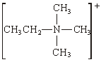 (Br–) + can be on N or outside brackets as shown
1
nucleophilic substitution
1
[9]

3. Mechanism
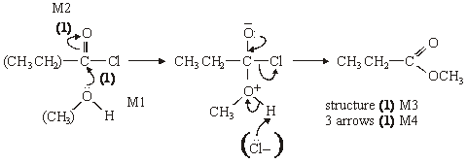
Name of organic product: methylpropanoate (1)
5
Notes
extra curly arrows are penalised
alone loses M2 but can score M1 for attack on C+, similarly
in M4, allow extra: Cl– attack on H, showing loss of H⁺
[5]

Organic points
(1) Curly arrows: must show movement of a pair of electrons,
i.e. from bond to atom or from lp to atom / space
e.g.
(2) Structures
penalise sticks (i.e. 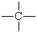) once per paper
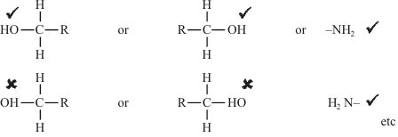
Penalise once per paper
allow CH₃– or –CH₃ or or CH₃
or H₃C

4. (a) Melting range would be
wide (>3 deg C) / not sharp
Allow melts over a range of temperatures.
1
below / before the true m.p.
Do not allow ‘above or below’.
1
(b) Temperature on thermometer not the same as the sample
Allow sample heats up at a different / higher / lower rate than thermometer.
1
[3]

5. (a)
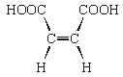
1
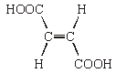
1
NB The bonds shown in the structure must be correct
Isomerism: E-Z isomerism
If written answer is correct, ignore incorrect labelling of structures.
If no written answer, allow correctly labelled structures.
1
Both COOH groups must be on the same side/ close together/ cis
1
No rotation about C=C axis
1
Structure
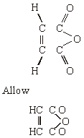
1
(c) e.g. 2NaOH + HO₂CCHCHCO₂H → NaO₂CCHCHCO₂Na + 2H₂O
Both H replaced
1
Balanced for atoms and charges
1
NB Allow ionic equations and 2NaOH + C₄H₄O₄ → C₄H₂O₄Na₂+ 2H₂O
Allow one if structure incorrect but molecular formula
correct
Allow one for a correct equation showing one H replaced
[8]
6. Advantage; reaction goes to completion, not reversible
or faster
1
Disadvantage; reaction vigorous/dangerous
(exothermic must be qualified)
or HCl(g) evolved/toxic
or CH₃COCl expensive
NB Allow converse answers
Do not allow reactions with other reagents e.g. water
or ease of separation
1
[2]

7. (a)
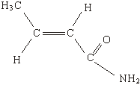
(allow 1 for amide even if not C₄H₇NO, i.e. RCONH₂)
(if not amide, allow one for any isomer of C₄H₇NO which shows
geometric isomerism)
2
(b)
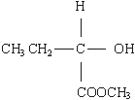
1
[3]
8. (a) (nucleophilic) addition-elimination;
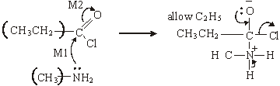

(M3 for structure)
(M4 for 3 arrows and lone pair)
(M2 not allowed independent of M1, but allow M1 for correct attack
on C+ if M2 show as independent first.)
(+on C of C=O loses M2 but ignore δ+ if correct)
(Cl– removing Ft loses M4)
1
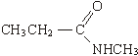
(If MS lost above for wrong C chain, do not penalise same error again here)
5

(b) M1 CH₃CH₂COCl + H₂O → CH₃CH₂COOH + HCl 1
(penalise wrong alkyl group once at first error)
1
M2 M_{r} of CH₃CH₂COCl = 92.5 1
(if Mr wrong, penalise M2 only)
1
M3 moles of CH₃CH₂COCl = 1.48/92.5 = 0.016 1
1
M4 moles NaOH = 2 × 0.016 = 0.032 1
(allow for × 2 conseq to wrong no of moles)
1
M5 volume of NaOH = 0.032/0.42 = 0.0762 dm³ or 76.2 cm³ 1
(with correct units)
(if ×2 missed in M4 lose M5 also)
1
[11]

9. (a) M1 CH₃CH₂CH₂COOH
not C₃H₇COOH
1
M2 CH₃CH₂OH or C₂H₅OH
1
M3 CH₃CH₂CH₂COOCH₂CH₃ + H₂O
allow C₃H₇COOC₂H₅
penalise M3 for wrong products and unbalanced equation
1
M4 H₂SO₄ or HCl or H₃PO₄ conc or dil or neither
not HNO₃
1
(b) M1 CH₃CH₂CH₂CH₂OH
1
not C₄H₉OH
M2 (CH₃CO) ₂O
1
M3 → CH₃COOCH₂CH₂CH₂CH₃ + CH₃COOH
allow CH₃COOC₄H₉
penalise M3 for wrong products and unbalanced equation
1
(c) (nucleophilic) addition-elimination
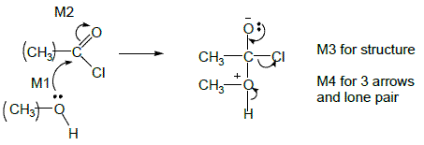
not acylation alone
M2 not allowed indep of M1 but allow M1 for correct attack on C+
+C=O loses M2
only allow M4 after correct or v close M3
ignore Cl– removing H⁺
5
(d)
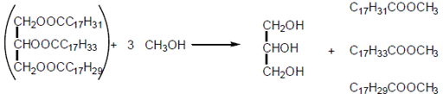
(1) (1) (1)
ignore errors in initial triester
First mark for 3CH₃OH
Third mark for all three esters
3
[15]
10. (a) Nucleophilic substitution
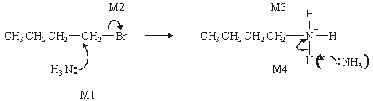
1
M1, M2 and M4 for arrows, M3 for structure of cation
(Allow M2 alone first, i.e. SN1 formation of carbocation)
(Penalise M4 if Br– used to remove H⁺)
4
(b) Step 1 CH₃CH₂CH₂CN 1
CH₃CH₂CH₂Br + KCN → CH₃CH₂CH₂CN + KBr balanced
1
(or CN–) (or Br–)
(not HCN)
1
Step 2 CH₃CH₂CH₂CN + 2H₂ → CH₃CH₂CH₂CH₂NH₂
(or 4[H])
1
(c) Lone pair (on N) (in correct context)
1
R group increases electron density / donates electrons /pushes
electrons / has positive inductive effect
1
(d) CH₃CH₂N(CH₃)₂
1
[11]

11. 1-chloropropane no visible change
Accept ‘small amount of precipitate’ or ‘precipitate forms slowly’.
1
ethanoyl chloride white precipitate
Accept ‘large amount of precipitate’ or ‘precipitate forms immediately’.
1
[2]

12. A
[1]
13. A
[1]
14. C
[1]
15. C
[1]
16. D
[1]
17. A
[1]
18. D
[1]

