A LEVEL CHEMISTRY
AMINO ACIDS, POLYMERS, ORGANIC SYNTHESIS AND BIOCHEMISTRY
ASSESSED HOMEWORK
Answer all questions
Max 80 marks

Name ……………………………………………………………..

Mark ……../80 ……....% Grade ………

- Lysine and alanine are two amino acids.

 | 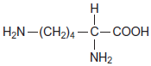  lysine | 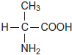  alanine

(a) Give the IUPAC name of lysine.
........................................................................................................................
(1)
(b) Draw structures to show the product formed in each case when lysine reacts with
(i) an excess of aqueous HCl

(1)
(ii) an excess of aqueous NaOH

(1)
(iii) methanol in the presence of a small amount of concentrated H₂SO₄

(1)
(c) Draw a dipeptide formed from one molecule of lysine and one molecule of alanine.

(1)
(Total 5 marks)

2. The amide or peptide link is found in synthetic polyamides and also in naturally
occurring proteins.
(a) (i) Draw the repeating unit of the polyamide formed by the reaction of propanedioic acid with hexane-1,6-diamine.

(2)
(ii) In terms of the intermolecular forces between the polymer chains, explain why polyamides can be made into fibres suitable for use in sewing and weaving, whereas polyalkenes usually produce fibres that are too weak for this purpose.
.............................................................................................................
.............................................................................................................
.............................................................................................................
.............................................................................................................
.............................................................................................................
.............................................................................................................
(3)
(b) (i) Name and outline a mechanism for the reaction of CH₃CH₂COCl with CH₃NH₂
Name of mechanism............................................................................
Mechanism

(5)
(ii) Give the name of the product containing an amide linkage that is formed in the reaction in part (b) (i).
.............................................................................................................
(1)

(c) The dipeptide shown below is formed from two different amino acids.
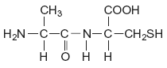
Draw the structure of the alternative dipeptide that could be formed by these two amino acids.

(1)
(d) The amino acids serine and aspartic acid are shown below.
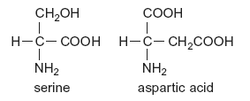
(i) Give the IUPAC name of serine.
.............................................................................................................
(1)
(ii) Draw the structure of the species formed when aspartic acid reacts with aqueous sodium hydroxide.

(1)
(iii) Draw the structure of the species formed when serine reacts with dilute hydrochloric acid.

(1)
(iv) Draw the structure of the species formed when serine reacts with an excess of bromomethane.

(1)
(Total 16 marks)
3. (a) The structure below shows the repeating unit of a polymer.
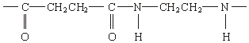
By considering the functional group formed during polymerisation, name this type of polymer and the type of polymerisation involved in its formation.
Type of polymer ...........................................................................................
Type of polymerisation .................................................................................
(2)
(b) Draw the structure of the species present in solid aminoethanoic acid, H₂NCH₂COOH

(1)
(c) Explain why the melting point of aminoethanoic acid is much higher than that of hydroxyethanoic acid, HOCH₂COOH
......................................................................................................................
......................................................................................................................
......................................................................................................................
(2)
(Total 5 marks)

4. (a) Consider the tripeptide shown below that is formed from three amino acids, K, L and M.
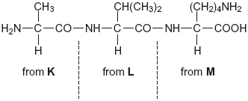
(i) Name the process by which the tripeptide is split into three amino acids.
.............................................................................................................
(1)
(ii) Give the IUPAC name for the amino acid K.
.............................................................................................................
(1)
(iii) Draw the structure of the zwitterion of amino acid L.

(1)
(iv) Draw the structure of the species formed by amino acid M at low pH.

(1)
(b) Consider the amino acid serine.
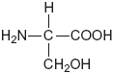
(i) Draw the structure of the product formed when serine reacts with an excess of CH₃Br

(1)
(ii) Draw the structure of the dipeptide formed by two molecules of serine.

(1)
(Total 6 marks)
5. (a) Name compound Y, HOCH₂CH₂COOH
......................................................................................................................
(1)
(b) Under suitable conditions, molecules of Y can react with each other to form a polymer.
(i) Draw a section of the polymer showing two repeating units.

(1)
(ii) Name the type of polymerisation involved.
.............................................................................................................
(1)
(c) When Y is heated, an elimination reaction occurs in which one molecule of Y loses one molecule of water. The organic product formed by this reaction has an absorption at 1637 cm^{–1} in its infrared spectrum.
(i) Identify the bond that causes the absorption at 1637 cm^{–1} in its infrared spectrum.
.............................................................................................................
(1)
(ii) Write the displayed formula for the organic product of this elimination reaction.

(1)
(iii) The organic product from part (ii) can also be polymerised.
Draw the repeating unit of the polymer formed from this organic product.

(1)
(d) At room temperature, 2-aminobutanoic acid exists as a solid.
Draw the structure of the species present in the solid form.

(1)
(e) The amino acid, glutamic acid, is shown below.
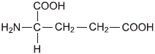
Draw the structure of the organic species formed when glutamic acid reacts with each of the following.
(i) an excess of sodium hydroxide

(1)
(ii) an excess of methanol in the presence of concentrated sulfuric acid

(1)
(iii) ethanoyl chloride

(1)
(Total 10 marks)

6. Isomer Y is used in the production of the polymer Kevlar:
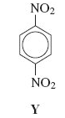
Y is first reduced to the diamine shown below.
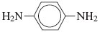
(a) Identify a suitable reagent or mixture of reagents for the reduction of Y to form this diamine. Write an equation for this reaction using [H] to represent the reducing agent.
.............................................................................................................
.............................................................................................................
.............................................................................................................
.............................................................................................................
(2)
(b) This diamine is then reacted with benzene-1, 4-dicarboxylic acid to form Kevlar.
Draw the repeating unit of Kevlar.

(2)
(c) Kevlar can be used as the inner lining of bicycle tyres. The rubber used for the outer part of the tyre is made of polymerised alkenes.
State the difference in the biodegradability of Kevlar compared to that of rubber made of polymerised alkenes.
Use your knowledge of the bonding in these polymer molecules to explain this difference.
.............................................................................................................
.............................................................................................................
.............................................................................................................
.............................................................................................................
.............................................................................................................
.............................................................................................................
(4)
(Total 8 marks)

7. Draw the repeating unit of the polyester Terylene that is made from benzene-1,4-dicarboxylic acid and ethane-1,2-diol.
Although Terylene is biodegradeable, it is preferable to recycle objects made from Terylene.
Give one advantage and one disadvantage of recycling objects made from Terylene.
......................................................................................................................
......................................................................................................................
......................................................................................................................
......................................................................................................................
......................................................................................................................
......................................................................................................................
......................................................................................................................
......................................................................................................................
(4)
(Total 4 marks)

8. Common substances used in everyday life often contain organic compounds.
(a) State an everyday use for each of the following compounds.
(i) CH₃(CH₂)₁₇COO– Na⁺ ......................................................................
(1)
(ii) CH₃(CH₂)₁₉COOCH₃ ..........................................................................
(1)
(iii) [C₁₆H₃₃N(CH₃)₃]⁺ Br– ..........................................................................
(1)
(b) The following structures are the repeating units of two different condensation polymers.
For each example, name the type of condensation polymer. Give a common name for a polymer of this type.
(i) 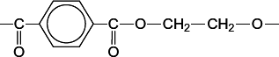
Type of condensation polymer .............................................................
Common name ....................................................................................
(2)
(ii) 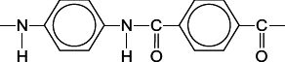
Type of condensation polymer .............................................................
Common name ....................................................................................
(2)
(iii) Explain why the polymer in part (b)(ii) has a higher melting point than the polymer in part (b)(i).
...............................................................................................................
...............................................................................................................
...............................................................................................................
(2)
(Total 9 marks)

9. (a) Synthetic polyamides are produced by the reaction of dicarboxylic acids with compounds such as H₂N(CH₂)₆NH₂
(i) Name the compound H₂N(CH₂)₆NH₂
.............................................................................................................
(ii) Give the repeating unit in the polyamide nylon 6,6.
.............................................................................................................
(2)
(b) Synthetic polyamides have structures similar to those found in proteins.
(i) Draw the structure of 2-aminopropanoic acid.

(ii) Draw the organic product formed by the condensation of two molecules of 2-aminopropanoic acid.

(2)
(c) Compounds like H₂N(CH₂)₆NH₂ are also used to make ionic compounds such as X, shown below.
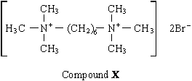
(i) X belongs to the same type of compound as (CH₃)₄N⁺Br–
Name this type of compound.
.............................................................................................................
(ii) State a reagent which could produce X from H₂N(CH₂)₆NH₂ and give a necessary condition to ensure that X is the major product.
Reagent .............................................................................................
Condition ............................................................................................
(iii) Name the mechanism involved in this reaction to form X.
.............................................................................................................
(4)
(Total 8 marks)
10. Organic chemists use a variety of methods to distinguish between compounds. These methods include analytical and spectroscopic techniques.
The following compounds can be distinguished by observing what happens in test-tube reactions.
For each pair, suggest a suitable reagent or reagents that could be added separately to each compound in order to distinguish them.
Describe what you would observe with each compound.
(i)
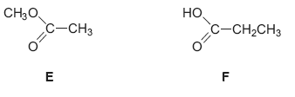
.............................................................................................................
.............................................................................................................
.............................................................................................................
.............................................................................................................
.............................................................................................................
.............................................................................................................
(3)
(ii)
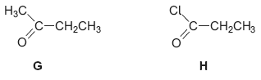
.............................................................................................................
.............................................................................................................
.............................................................................................................
.............................................................................................................
.............................................................................................................
.............................................................................................................
(3)

(iii)
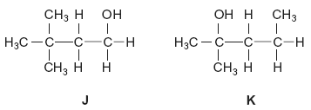
.............................................................................................................
.............................................................................................................
.............................................................................................................
.............................................................................................................
.............................................................................................................
.............................................................................................................
(3)
(Total 9 marks)

