Physics AS Experimental procedures
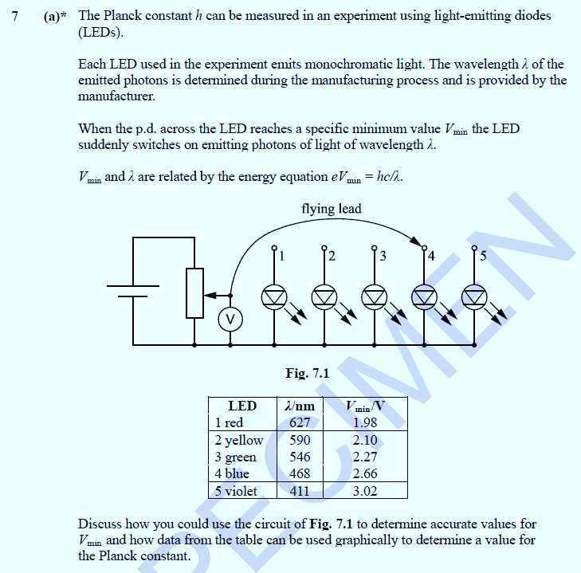
- Determining Planck’s constant from LEDs:

- Adjust the potentiometer so the volt meter records 0V and then connect the flying lead to the first LED.
- Gradually adjust the potentiometer so that the voltmeter reading increases until the LED only just begins to light up (strike).
- Place a black opaque tube around the LED to look down in order to increase the accuracy of V_{min}.
- Record the voltmeter reading as V_{min} and do several repeats to obtain a mean value for this.
- Repeat steps 1 to 4 for the other LEDs.
- Plot a graph of V_{min} against 1/ λ
- Draw a straight line of best fit that intercepts the origin 0,0
- The graph is in the form y = mx + c where V_{min} = hc/eλ i.e. V_{min} = hc/e X 1/ λ
and so the gradient = hc/e
∴ h = gradient X e/c

Note: To work out the gradient use V_{min} / (1/ λ) i.e. V_{min} X λ

The physics behind the experiment
At the threshold p.d. V_{min ,} the energy transferred by each electron is approximately equal to the energy of each photon emitted. There is a one-to-one relationship.
Since W = VQ Energy of electron = p.d. * 1.60 X 10^{_19}
= Energy of photon
∴ eV = hf₀
If this equation is expressed in terms of wavelength then eV = hc / λ
This information could be used for a single LED to gain a value for h but it is more accurate to get a number of measurements form LEDs with different wavelengths.
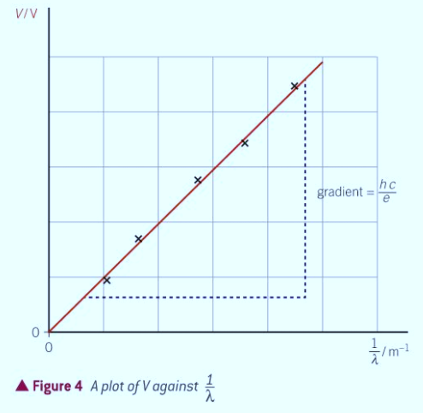
A straight line of best fit through the origin is drawn given that at V_{min} = 0 , no photons are emitted.

- Determining work function from the photoelectric effect:
In the following circuit, indecent radiation is shown onto the cathode of the photocell. This liberates photoelectrons with a maximum amount kinetic energy (the only energy they possess is in the form of kinetic energy, E_{k} ).

Their energy is equal to the incident photon’s total energy minus the work function (energy needed to release them): E_{k} = hf - Ø

The electrons can pass from the cathode to the anode due to this and so a current can flow in the circuit.

If a potential difference is then applied across the photocell (in an opposing direction) and increased, you will see the current decreases until it reaches zero and no electrons flow.
Since the electron’s original maximum kinetic energy is given by:
E_{Kmax} = hν – ϕ
In order to stop an electron with this amount of kinetic energy, you have to impose an electric field such that it will lose exactly this amount of energy while traversing it, so that it stops just slightly before reaching the other end of the photocell.
The energy imposed by the electric field in an opposite direction to the photoelectrons and ifs given by W = eV₀ Where V₀ = stopping p.d. and Q = e = 1.60*10⁻¹⁹ C

Therefore eV₀ is the energy required to stop the photoelectrons.
E_{Kmax}= eV₀
Once the stopping potential is applied the electrons are still liberated by the incident radiation but they can’t flow anymore. Bringing this together gives us the equation that can be used to determine the work function.
Ø = hf - Ek OR Ø = hf - eV₀
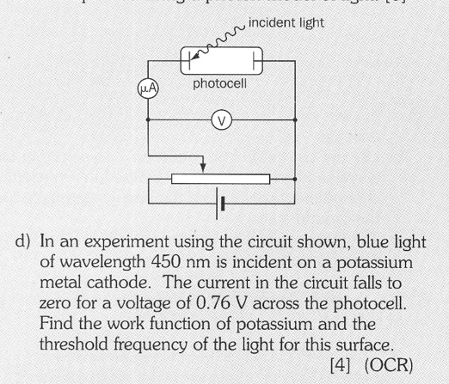

Answer/method to sample question
Photon energy, hf = hc / λ = ( 6.63 X 10⁻³⁴ X 3 X 10⁸ ) / (450 X 10⁻⁹ )
= 4.42 X 10⁻¹⁹ J
hf = Ø + E_{k} & given that E_{k} = eV₀ …
Ø = hf - eV₀ Ø = ( 4.42 X 10⁻¹⁹ ) - ( 0.76 X 1.60 X 10⁻¹⁹ )
Ø = 3.2 X 10⁻¹⁹ J (2 s.f.)
The threshold frequency, f₀ = Ø/h
“since the work done is the energy required to liberate photoelectrons from the surface atoms of a metal” and hf₀ = Ø “
f₀ = (3.2 X 10⁻¹⁹) / (6.63 X 10⁻³⁴ ) = 4.8 X 10¹⁴ Hz (2 s.f.)

