ALDEHYDES, KETONES AND OPTICAL ISOMERISM

HW MS
1. (i) molecules with same structure / structural formula (1)
but with bonds (atoms or groups) arranged differently in
space (3D) (1)
(ii) Plane polarised light (1)
Rotated (equally) in opposite directions (1)
4
[4]
2. (a) (i) Reagent: pentan-2-one (1)
or 2-pentanone
but not pent-2-one or pentyl
(ii) Reagent: Tollen’s or Fehling’s (1)
Observation with E: no reaction (1)
Observation with F: silver mirror or red ppt (1)
for E and F

Test | Tollens | Fehlings or Benedicts | iodoform or I₂/NaOH | acidified K₂Cr₂O₇ | Schiff’s
observation with E | no reaction | no reaction | yellow (ppt) | no change | no reaction
observation with F | silver or mirror or grey or ppt | red or ppt  not red solution | no reaction | goes green | goes pink

4
(c) 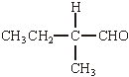 (1)
must be aldehyde. Allow C₂H₅ for CH₃CH₂ otherwise this is the only answer
1
[5]
3. (i) CH₃CH₂CHO + HCN → CH₃CH₂CH(OH)CN OR
C₂H₅CH(OH)CN
aldehyde must be –CHO brackets optional
1
2-hydroxybutanenitrile OR 2-hydroxybutanonitrile
no others
1
(ii) nucleophilic addition
1
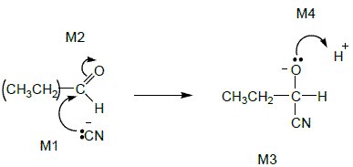
M1 includes lp and arrow to Carbonyl C and minus charge (on either C or N)
Not allow M2 before M1, but allow M1 to C⁺ after non-scoring carbonyl arrow
Ignore δ+, δ– on carbonyl group, but if wrong way round or full + charge on C lose M2
M3 for correct structure including minus sign. Allow C₂H₅
M4 for lp and curly arrow to H⁺
4
(iii) (propanone) slower OR propanal faster
1
inductive effects of alkyl groups
OR
C of C=O less δ+ in propanone
OR
alkyl groups in ketone hinder attack
OR
easier to attack at end of chain
if wrong, no further marks
1
[9]

4. L
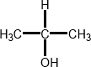
Allow (CH₃)₂CHOH or CH₃CH(OH)CH₃
Allow name propan–2–ol
Penalise contradiction of name and structure
1
M
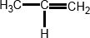
Allow CH₃CH=CH₂
Allow name propene
ignore -1- but penalise other numbers
Penalise contradiction of name and structure
1
Step 1 NaBH₄ or LiAlH₄
Zn/HCl or Sn/HCl
or H₂/Ni or H₂/Pt
Ignore name if formula is correct
ignore solvent
ignore acid (for 2nd step) but penalise acidified NaBH₄
Apply list principle for extra reagents and catalysts.
M1
1
(nucleophilic) addition
Addition (not nucleophilic)
Penalise electrophilic
Ignore reduction
M2
1

Step 2 conc H₂SO₄ or conc H₃PO₄ or Al₂O₃
Apply list principle for extra reagents and catalysts.
M3
1
elimination
Independent from M3
penalise nucleophilic or electrophilic
ignore dehydration
M4
1
Step 3 HBr
Apply list principle for extra reagents and catalysts.
M5
1
electrophilic addition
Independent from M5
M6
1
[8]
5. (a) Nucleophilic addition
NOT reduction
1
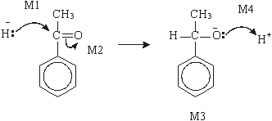

M2 not allowed independent, but can allow M1 for attack of H– on C+ formed
4
(b) dehydration or elimination
1
(conc) H₂SO₄ or (conc) H₃PO₄
allow dilute and Al₂O₃
Do not allow iron oxides
1
[7]

6. (a) (i) 2-hydroxypropanoic acid
OR
2-hydroxypropan(-1-)oic acid
Do not penalise different or missing punctuation or extra spaces.
Spelling must be exact and order of letters and numbers as here.
Can ignore −1− before –oic, but penalise any other numbers here.
1
(ii) C₁₂H₂₂O ₁₁ + H₂O 4CH₃CH(OH)COOH
Allow 4C₃H₆O₃
OR
C₁₂H₂₂O₁₁ + H ₂O 2CH₃CH(OH)COOH + C₆H₁₂O₆
Allow 2C₃H₆O₃
1
(b) (i) Nucleophilic addition
M4 for lp, arrow and H+
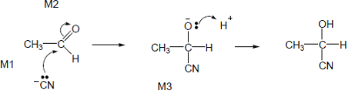
• M1 lp and minus must be on C
• M1 and M4 include lone pair and curly arrow.
• M2 not allowed independent of M1, but allow following some attempt at attack on carbonyl C
• allow M1 for correct attack on C+
• + rather than δ+ on C=O loses M2
• M3 is for correct structure including minus sign but lone pair is part of M4
• Allow arrow in M4 to H of H-CN with arrow forming cyanide ion.
5
(ii) Equal mixture of enantiomers / (optical) isomers
1
(iii) (Plane) polarized light
If missing no further mark.
1
(Polarised light) rotated by single enantiomer but unaffected by racemate
Both needed; not allow bend, twist etc.
1
[10]

7. (a) Nucleophilic addition
1

M4 for lp, arrow and H+
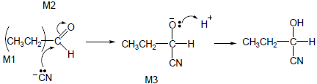
Allow C₂H₅₋ for CH₃CH₂₋

• M1 and M4 include lone pair and curly arrow.
• Allow: CN⁻ but arrow must start at lone pair on C.
• M2 not allowed independent of M1, but allow M1 for correct attack on C+.
• + rather than δ+ on C=O loses M2.
• Penalise incorrect partial charges.
• M3 is for correct structure including minus sign but lone pair
is part of M4.
• Penalise extra curly arrows in M4.
4
(b) (i) M1 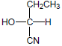
M1 for correct structure of product of part (a).
Allow C₂H₅₋ for CH₃CH₂₋.
Penalise wrongly bonded, OH or CN or CH₂CH₃ once only in clip.
1
M2
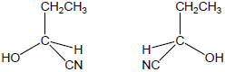
M2 cannot be gained by simply swapping two or more groups with no attempt to show a mirror image., e.g. do not allow M2 for
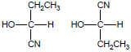
because these do not show the enantiomers as mirror images.
Students must show an attempt at mirror images, eg allow
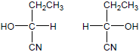
ie vertical groups same and horizontal swapped as if there was a mirror between them
No mirror need be shown
Do not penalize wedge bond when wedge comes into contact with both C & N
However these two could score M2 if placed as below as if with a “mirror” horizontally between them.
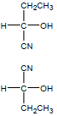
1
(ii) M1 (Plane) polarized light
M2 only scores following correct M1
1
M2 Rotated in opposite directions (equally) (only allow if M1 correct or close)
Not just in different directions but allow one rotates light to the left and one to the right.
Not molecules rotate.
1
(c) 2-hydroxybutane(-1-)nitrile
1
[10]

8. (a) nucleophilic addition
1
Attack by HCN loses M1 and M2
M2 not allowed independent of M1, but
allow M1 for correct attack on C+
+C=O loses M2
M2 only allowed if correct carbon attacked
allow minus charge on N i.e. :CN–
4
M3 for completely correct structure not including lp
allow C₃H₇ in M3
M4 for lp and arrow
allow without –
1
2-hydroxy-2-methylpentan(e)nitrile
allow 2-hydroxy-2-methylpentanonitrile
(b) Product from Q is a racemic mixture/equal amounts of enantiomers
if no reference to products then no marks;
1
racemic mixture is inactive or inactive explained
not Q is optically active or has a chiral centre etc
1
Product from R is inactive (molecule) or has no chiral centre
1
[9]

9. (a) (i) Green
Ignore shades of green.
1
(ii) Excess acidified potassium dichromate(VI)
1
Reflux (for some time)
1
In the diagram credit should be given for
• a vertical condenser
Lose M3 and M4 for a distillation apparatus.
1
• an apparatus which would clearly work
Do not allow this mark for a flask drawn on its own.
Penalise diagrams where the apparatus is sealed.
1
(iii) Distillation
1
Immediately (the reagents are mixed)
1
(b) Keep away from naked flames
Allow heat with water-bath or heating mantle.
If a list is given ignore eye protection, otherwise lose this mark.
1
(c) (i) Tollens’ or Fehling’s reagents
Incorrect reagent(s) loses both marks.
Accept mis-spellings if meaning is clear.
1
Silver mirror / red ppt. formed
Accept ‘blue to red’ but not ‘red’ alone.
1
(ii) Sodium carbonate (solution) / Group II metal
Allow indicator solutions with appropriate colours.
Accept any named carbonate or hydrogen carbonate.
1
Effervescence / evolves a gas
Accept ‘fizzes’.
1

(d) Propanoic acid
If this mark is lost allow one mark if there is reference to stronger intermolecular forces in the named compound.
Lose M1 and M3.
1
Contains hydrogen bonding
1
Some comparison with other compounds explaining that the intermolecular forces are stronger in propanoic acid
1
[15]

10. B
[1]
11. D
[1]
12. B
[1]

